British Canoeing Marathon Racing Committee
Minutes of the Committee Meeting held at 9am on 30th August 2021
Meeting held at Falcon Rowing & Canoeing Club, Oxford, with some joining via Zoom.
If your initials are down for action please ensure that you follow up the matter concerned and report the outcome back to the Secretary well before our next meeting. Our next meeting is Saturday 20th November.
1. Present

Stan Missen (SM) (Chair)
James Smythe (JS)
Dyson Pendle (DP)
David Enoch (DE)
Siobhan Urquhart (SU)
Brian Chapman (BrC)
Scott Hynds (SH)
Jim Rossiter (JR)
Bryn Price (BP)
Graham Warland (GW)
Dan Seaford (DMS)
Holly Mobbs (HM)
Evan Shepherd (ES)
These people are referred to by their initial’s hereafter in the Minutes.
Apologies for absence were received from Roland Lawler, Nanette North, Dave Sackman and Kat Wilson
- Approval of Minutes of Meeting 10th April 2021
The minutes of the meeting of 10th April were approved by the Committee with one correction – the Central Grant figure is up to £35k. They will now be published as final.
Action: JS
- Matters Arising
a) JS will ensure RMAs have had an email inviting them to future meetings
b) BP / MN will email RMAs about the MRC’s offer to purchase changing tents for each region.
c) No further progress has been made on the Speed Series since the test events run by Norwich CC. The MRC feels that this is something the SRC should be leading on as the aim is to create a programme of regional “sprint” type events, however apart from Wendy Dodson’s efforts no further support has been forthcoming.
d) The earliest date that we could host a major international in the UK and get support from British Canoeing is now 2027
e) BP reported that British Canoeing have agreed that Masters teams can use our previous seasons’ Joma kit branded with “Masters”. He asked if the masters could purchase the MRC’s old stock. As this has been written off in accounts, we agreed that they could have it for free. (Action: BP to discuss with DE)
4. Governance
a) The ACM went well via online meeting, despite some interruption from a mischief-maker. The Committee welcomed Holly Mobbs and Evan Shepherd to their first full meeting.
b) The Committee provisionally agreed responsibilities for the year ahead, which are outlined on the table below. Notable changes were:-
- Communications needs to be shared more widely, so JS and SU will share website and comms with HM.
- ES will support MN specifically on Geoff Sanders rules, with BP supporting on rules generally.
- GW will seek help from Will Abson to make the Race Records job simpler.
- SH agreed to act as support to RL as Rankings Officer
- There was concern on progress of the Race Management software. DMS, ES and JS volunteered to take charge of the group managing this area and we agreed on the need to have a new formal agreement in place with Will Abson. SM reported that British Canoeing are happy to support spending on certain items and believes this would include this development.
- JS is withdrawing from the Selection Committee, which will need a new Chair and a new member. DE proposed approaching Pete Wilkes to become a voting member, as he contributed very well during the meetings this season. (Action: Selection Committee – Kat to action?)

 |  | Elected |  |  |  |  |  |  |  |  |  |  |  |  | Co-opted/SCA rep (*)
 |  | Stan | Mick | David E | James | Graham | Kat | Holly | Evan | Siobhan | Bryn | Dyson | David S | Roland | Nettie | Scott | Brian* | Dan
GENERAL | Chair
 | Vice-Chair
 | Secretary
 | Treasurer
 | Website, Social & Comms
 | Safeguarding
 | Rules
 | Equality
 | Coaching
DOMESTIC | Major Events
 | Regional Adviser liaison
 | Club & Volunteer Support
 | Race Records
 | Race Management
 | Calendar
 | Rankings
 | Event Safety
 | Trophies
INTL | Athlete Dev
 | Junior Dev
 | Intl Logistics
 | Intl kit
 | Masters
 | Event planning
 | Selection Cttee
c) JS reported on the progress of the Gender Equality working group. The new ‘sword’ trophy for SWK1 was awarded at the Nationals, and equality of medals available across genders and age groups has been established.
The proposal to create a national ranking based on race results will be progressed once the Race Management system can better support it with data (Action: JS).
JS approached Newbury CC about having equality in the Watersides classes from 2022, James Treadgold agreed to take this to their club committee for agreement.
The MRC will be approaching RMAs to discuss how to deliver on the proposal to buy changing tents for each region. (Action: MN, BP)
5. Finance
DE reported that budgets remain fluid due to the COVID situation. While we had originally expected to collect only around £1k in levy revenues, £4.5k has already come in from the races that were able to run. The cancellation of the trip to the French Nationals has also saved around £6.5k. As a result, our reserves could go up to around £58k or £59k.
The cost of the World Championships in Romania for us is projected to be around £37k, although the costs of COVID testing are still uncertain as rules change.
As a result, we may not need to request/draw the full BC Central Grant of £35k.
6. Domestic Racing
a) The Committee agreed to start the 2021-22 Hasler Season with effect from 1st September, now that Covid restrictions have been largely lifted. With effect from the start of the season, points for a division win will be increased to 50points per seat (as previously decided and announced by the Committee). The cut-off where points reduce to 1 will remain at 110% of the winner’s time (Action: SU/HM to put comms on website)
b) Pace in developing the race management software in the last year has not been as rapid as hoped and additional committee input is required, JS, DJS and Will Abson have started conversations about moving this forward, with now DJS taking the lead. The desired end result and roadmap have been agreed, with race-day software focussing on calculating finish times, and online solutions providing the rest, from ranking list and race entry to club points, P&Ds and Hasler qualifying status. The new approach will still accommodate races with no 4G signal or internet connection.
Will Abson has indicated his willingness to develop the post-race system free of charge, however the Committee agreed that it would be best to have a formal agreement with Will, and some payment to him, to ensure that the resulting system would be something the MRC has full ownership & control of.
c) The Committee discussed the Racing Levy, and whether use of software (including the race entry system and RACMAN) should be limited to those races which collect it (currently defined as Category A races).
SM pointed out that there has been resistance by some clubs to collecting the levy in the past and this had increased during Covid, as ‘special’ events have been organised by some. This had increased due to the pressures of lockdown and reduced racing numbers and uncertainty over the normal calendar. Royal CC had recently declined to pay the levy after their summer marathon race, since the Hasler season had been suspended. (n.b. following the meeting, Royal CC agreed to pay the levy on entries from this race as they had agreed to do so when submitting it to the calendar)
The Committee agreed that it is best to explain again the benefits of, and reasons for the levy rather than to try to force it on races or require it in order to use MRC resources. The race entry software is such a useful tool for all sorts of races that we agreed to offer if without restriction to any canoe race organiser, of any type of race.
Following the meeting, JS wrote an article explaining the levy for the website which attracted positive attention, and which we can refer race organisers to.
The Committee discussed whether any rules should be imposed on race organisers using the race entry system, following a complaint about a race organiser refusing refunds for entries withdrawn/changed after the deadline. The ability for club team leaders to enter paddlers in bulk can cause this problem, if paddlers are entered before they are asked if they can attend. The conclusion was that we should leave terms and conditions of entry to the organiser and the paddlers and not at this early stage get involved as a Committee. (Action: DMS ) DMS to add a disclaimer along the following lines to the appropriate page – ‘ please do not enter and pay for your, or anyone else’s entry until you are certain that you/they can attend. Refunds, for whatever reason, are at the complete discretion of the individual race organiser and may not be offered.’
d) A question was raised by Rob Passmore of Tonbridge CC about allowing US-style C-boats to be used in marathons. These are currently disallowed due to ICF rules regarding concave sections. The Committee agreed that, like surf skis were, these should be allowed to compete in marathons on a similar basis, as they do not offer a performance advantage. However they would not be permitted for assessment races as they would not be compliant for ICF events. MN agreed to amend the rules accordingly and bring to the November meeting for confirmation (Action: MN) It is thought that the concave hull design issue is currently under consideration by the ICF anyway.
7. Major Events
a) DJS presented the following report on the National Championships:
Reading Canoe Club hosted the Nationals 2021, under COVID restrictions. A total of 807 seats raced across the two days, this was down on 2019 where 1102 seats competed over the weekend.
Course
The tried and tested course was used operating between Caversham and Mapledurhm lock, however, leaving out the prom portage to minimise crowds gathering on the path and to enable a Covid safe event to be run.
Race Entry & Results
Entries were only available online using the new online entry system. This could be completed by the team leader or an individual. Results were generated using a modified Racman program and were published directly on the club website during the event.
National Champion Club
Initially Nottingham Canoe Club was awarded the club championship title, however, following the correction of two errors the title was awarded to Reading Canoe Club.
The two corrections; 1 Nottingham K2 was disqualified as only one paddle completed the course, a missing mixed K2 was added to the results, reducing the number of Nottingham K2 points by 1.
General Points
- Camping - Reading was unable to provide a campsite at the event as the local council stipulated a number of additional measures that the club was not able to meet in the time - or at least not without raising the cost of a pitch to significantly more than a hotel room
- Seeding was successfully introduced in some races. It was used for the two largest classes of Mixed K2 and U16 Men’s. Overall this was well communicated and received by paddlers.
- Time table -
The change to the Saturday timetable was to reduce the expected number on each start window and to attempt to split evenly over the day. This worked as expected but was the cause of the long Saturday which would have meant a full prize giving and an MRC ACM meeting would not be possible with the same format. Therefore we would not recommend this format for other years but was but was the right choice with Covid restrictions.
  - Sunday timetable was tweaked for the same reason but the result also gave better protection for the Mixed K2 which limits its impact on other races on course for a small impact on the length of the day. We recommend retaining this change for future events.
- Finish Line camera - a new prototype camera system recorded the finish, in addition to taking photos as boats cross the line. This proved a useful tool for resolving queries and tight finishes.
- Race control - was particularly quiet due to the no late entries and most queries solved via the camera system
New racing class - the new under 10 class had the first outing, although numbers were low, feedback has been positive. A few team leaders were chased to try and push entries up feedback suggests the Covid delays to their beginner course were the main reason for the lack of entries
- Non-quorate - classes that were non-quorate were advertised during the week to gain additional entries.
These entries were accepted after the entries closed but were not charged late entry fee. All classes with entries were given special dispensation from the MRC to be given medals even if the class was not quorate. This was well received.
- The briefing was given by video which seems to have been effective where people bothered to watch it. There seem to have been a few who did not (although not aware of many) and this is often the case with a live briefing also.
- We had a complaint about the rude and dangerous behaviour of some coaches following the races on the bikes along the prom on the Saturday. Following a request to not cycle on the prom and tighter marshalling, there were no further incidents on the Sunday.
- Atmosphere: the event village was well set up with good flow for paddler traffic. The retailers were visible and very accessible. There was a mix of internal and external catering which worked well. Commentary and music was broadcast into the event area giving a great event atmosphere.
Finances
The club made a profit of £7,702.53 form the event, showing that a host club, even due to the increased Covid costs, can still make reasonable profits form this prestigious event.
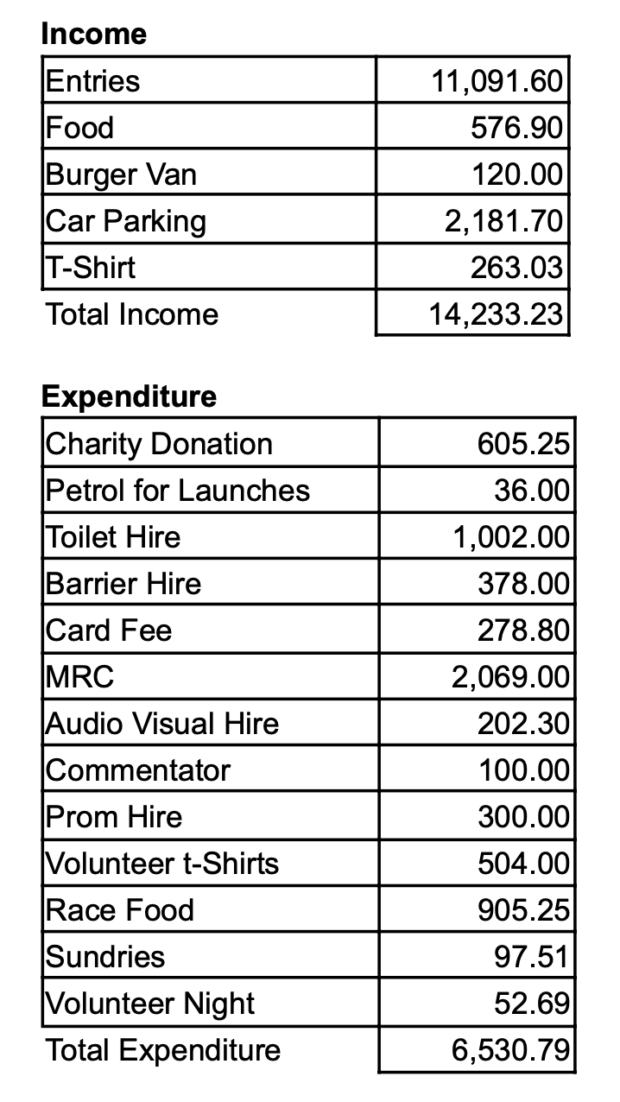
SM thanked and congratulated Reading CC on behalf of the Committee for having organised such a successful event despite the restrictions and difficulties.
DJS agreed to compile available resources on best practice in running a National Championships, to aid future organisers, as finding clubs to run the event is always difficult. The MRC is always available to run the results process if requested. (Action: DJS)
An organiser is needed for 2022, so please could all Committee members consider and discuss with their clubs and contacts (Action: comms team to post on website)
8. Internationals
a) JS outlined the 2021 assessment race programme, which included singles and doubles races at the Nationals, and a short-course race at Gloucester. While these races all went well, there was some feedback that Gloucester was too bumpy for a short lap race. A handful of athletes were unable to attend one or the other event due to self-isolation and track & trace requirements, highlighting the difficulties of having so few assessments, essentially down to COVID.
The Nationals highlighted the problem of crew boats, as classes were poorly attended, especially juniors. It is probable that COVID had prevented people from establishing and training crews across clubs. The Selection Committee chose to select a number of ‘scratch’ crews based on K1 results, as there were insufficient results in some classes to select established crews.
b) BRC outlined progress on scoping out the possibility of hosting a major international in the UK. The earliest British Canoeing will be able to support one would now be 2027, giving us 15 months in which to prepare a proposal deadline, by the ICF.
A group comprising BRC, JS, Jo Bates and Gemma Wiggs met on a call to discuss first steps. The conclusion was that our first objective must be to establish a ballpark budget and identify a venue where local authority support would enable us to run the event. BRC is working with British Canoeing on the budget, which is currently higher than what BC are willing to under-write.
9. Coaching & Development
a) SH reported that British Canoeing have centralised Level 3 racing coach course providers, bringing the already slow system to a halt. Pete Catterall, coach lead for non-Olympic disciplines at BC was intending to run a Level 3 course at a cost of between £900 and £1200 but SH was not sure of this was happening. The ICF are offering an online L3 equivalent for £1500.
Regarding the MRC and SRC bursaries, SH pointed out that many courses have been priced at the same level as the bursary, i.e. £100 per head, when a more reasonable fee for the provider would be £280, so it was important not to give the impression that the bursary equalled a free course. Also, members of Talent Club Partnership clubs do not qualify for a bursary, even if that club receives no funds from BC.
SH also reported that British Canoeing have been encouraging clubs to report more “near-miss” safeguarding and safety incidents, in a bid to better educate the community about risks and successful outcomes. However, responses have been very poor, either because of the fear of repercussions, or a cultural complacency about what constitutes a “near-miss”
b) The new combined junior skills days (bringing together the MRC, SRC and ENTS) kicks off at Wey KC on 18th September, and a talk at the September regatta. (Action: comms team to promote)
10. AOB
RL requested that the “Standards for Racing” in the Racing Handbook should include marathon standards again. JS reported that he had informed the SRC of our intention to collaborate on this again in 2022.
HM offered to liaise with the DW Committee regarding Schools racing (Action: HM to bring proposals to November meeting)
The debate about how to rank Divs 1-3 was again raised. Some in the community were unaware that there has been no rule imposing a rankings ceiling on women for nearly a decade, and there was concern that a recent female performance merited a promotion to Div 1 which had not been given.
ES reported that data from past races indicated that these divisions had a more consistent standard over time with the Rankings Officer being in control of P&Ds, compared to lower divisions whose P&Ds are done automatically. There was no appetite to change this arrangement at this stage, although it is and will always be discussed on at least an annual basis.
SM reminded the meeting that the official MRC outlet for news and announcements is the MRC website, which should then link through to facebook pages and other social media, not the other way around.
12. Meeting Dates 2021
- All-day meeting 20th November 2021 at Cropredy, nr Banbury 9.00am start prompt, finish at 3pm. Planned to be in-person meeting, sandwiches available for lunch, with Zoom available for those unable to travel.
PLEASE CONFIRM YOUR ATTENDANCE IN PERSON, IN ADVANCE TO JAMES, FOR CATERING ARRANGEMENTS.
The meeting closed at 11.30 am

